The School

Deeping St Nicholas Primary School opened its doors on the 2nd January 1877.

We are very fortunate to still have the original Headmaster Log, where Mr Hanley, the Head teacher, wrote: "I commenced school this morning with 5 [older] children and found that they had never been to school..."
The children still find the Head Teacher Logs fascinating as they provide a glimpse into school and village life in years gone by.

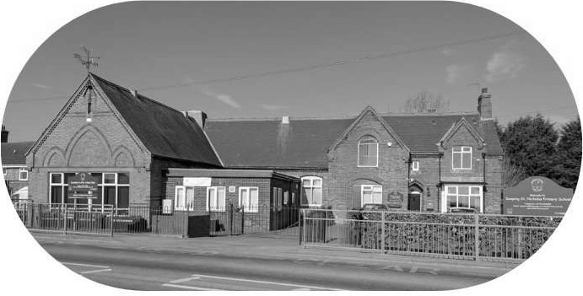

Our Vision

ln our inclusive and happy schools, we make sure everyone feels welcomed, valued and valuable. Our safe and inspiring learning environment helps us work towards achieving our best, in all that we do, so that we can become independent and resilient members of our wider community. Our shared values give us a foundation of challenge and support, helping to make a positive change in the world, as we strive to create a community of respect and aspiration, preparing everyone for their future

Our Ethos & Values

Our Dream it, Learn it, Be it principles-Read, Thin k, Respect, Aspire-are central to developing well-rounded individuals who are not only academically successf ul, but also empathetic, responsible, and reflective members of society. These principles are supported by our 4Rs and Core Values.

At The Stukeley Federation, our aim is to develop children into respectful, tolerant, thoughtful and determined young people. We aim to ensure that we improve the lives of the children by ena bling them to enjoy learning and to f ulfil their potential. There is a moral purpose and underlying rationale to all we do, and our Core Values of Respect, Politeness, Friendship, Honesty, Responsibility and Resilie nce support this. We understand it is vital for every child to succeed academically; our definition of learning is a change in long term memory, with pupils able to retain, recall, transfer and use learning in a range of contexts. We also know that children need to develop well personally and socially if they are going to lead fulfilled and happy professional and personal lives. We want our children to be aspirational about what they can become and encourage our pupils to 'Dream it, Learn it, Be it'.

Within the school's ethos we aim to:
• Promote a positive attitude to life-long learning, nurturing the development of self-esteem; leading to aspirational, independent learners who are prepared to be challenged and take risks in a diverse and ever-changing world
• Provide the children with valuable experiences and opportunities, through a broad, balanced a nd exciting curriculum, where learning is purposeful and fun
• Use a va riety of teaching strategies and resources effectively and creatively, encouraging each child to progress a nd attain to the highest possible sta ndards, in relation to their age and ability
• Strongly encourage parental involvement in the education of our children
• Demonstrate and foster respect for ourselves and others within the school and the global community
• Encourage moral values
• Value each child as an individual within the school

