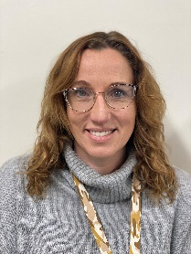
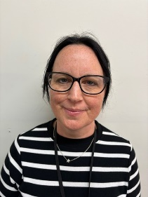
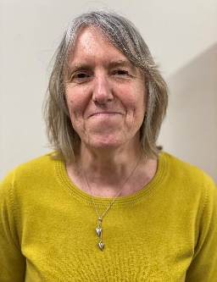

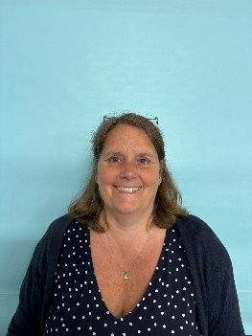

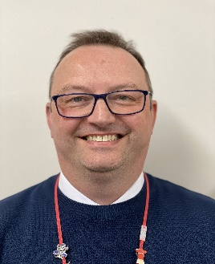



Miss Alicia Cassidy
Mrs Michele Holliday
Deputy Designated Safeguarding Lead
Mrs Felicity Stanberry

Mrs Michele Holliday

Mental Health Leads
Mr Iain Braid
Safeguarding Governor

Please ask to speak to a member of the safeguarding
team about safeguarding matter.
Mrs Helen Ward
Deputy Designated Safeguarding Lead

Mr Paul Houghton
Deputy Designated Safeguarding Lead
Mr Stewart Cuthbertson
Deputy Designated Safeguarding Lead
Mr Peter Bellamy
Designated Safeguarding Lead, Executive Headteacher

William Stukeley CofE Primary School
Safeguarding Team

